**USER MANUAL**

**Game Description:**

In this game, the player has to memorize the sequence of flashing random numbers from the seven segment display and enter those numbers in the same order using the toggle switches assigned for the User Input. After all the numbers have been flashed upon the seven segment display, the countdown timer starts within which the player has to enter their input. If player fails to give his input before timer goes to ‘0’ he looses and score goes to ‘0’. Also if he gives wrong input, he looses. The game iterates over a maximum of 5 levels, each level with varying values of the length of the sequence displayed and the countdown timer. If the player matches the entire sequence, he wins the round and goes on the next level. The scores of individual players will be stored along with the highest score recorded.

The player who gets the highest score will be declared with a separate green LED being turned on after the player has logged in. The winner of the game is declared by looking up at this green LED.

**How it works:**

Before the game begins, the players are provided with their User ID and Password. Only one player can play the game at a time. The player has to first authenticate the game using his/her 16-bit User ID and password through the designated toggle switches and the overload button to start the game. Our game comes with a total of pre-defined User ID’s and passwords for our team members and also an additional Guest User ID and password. The player also has a choice to reset their password after they login initially. But once the player starts playing the game, password resetting is not possible. Password resetting has to be one immediately after the player logs in. After successful authentication, the player is all set to play the game.

Once the player has logged in, he/she has to push the RNG button to generate the sequence of flashing random numbers. After all the numbers have been displayed, the countdown timer starts and the player then has to enter the binary forms of the numbers using the assigned toggle switches. If the player has entered the entire sequence correctly, he jumps to the next level. The player once again has to push the RNG button for the next level. Meanwhile, the individual score of the player will be stored along with the highest score recorded. A single toggle switch is used to see the scores of the players and the highest score. If the toggle switch is set to one, the individual score is displayed and if it is set to 0, the highest score will be displayed.

The player can continue to play the game even if he/she fails is any of the levels by pushing the RNG button again but if a failed case is encountered, the individual score will be driven back to zero which means the scores from previous levels no longer count. Also, a player can logout of the game anytime and log back in to continue to play the game from the same level where he left the game.

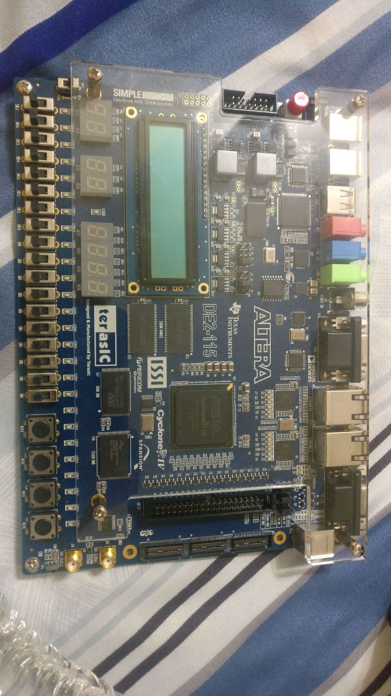

**User ID Overload Button RNG**

**Password Logout Button Timer**

**Score RNG Button Level**

**Answer Reset Button Score**

**How to play:**

* Push the Overload button to begin authentication.
* Enter your 16-bit User ID using the four assigned toggle switches and by pushing the same overload button for every 4 bits.
* Now, enter your 16-bit Password using the other four assigned toggle switches in the same manner as you entered the User ID.
* If you wish to change your password, firstly login using the given credentials and after successful authentication, push same auth button to begin password reset. Just like you did with password entry, give new password the same way.
* After that, push the RNG button to begin the game.
* A sequence of random numbers would be flashed upon the seven segment display and a countdown timer begins after all the numbers have been displayed.
* Before the timer hits zero, the player has to memorize the sequence displayed and enter their binary forms using another set of four assigned toggle switches and the same overload button which will load your input into the board.
* If all the numbers entered have matched correctly, the player enters the next level and his/her individual score will be updated.
* The player continues to play the game in the same way as above until the completion of all 5 levels.
* If a player fails to pass any level, it will be indicated with a red LED. The player can still continue to play the game but his score will be set back to zero.
* The winner of the game would be known if a separate green LED is on once the player logs in which indicated that he/she is the highest scorer.

**USERID and passwords**

|  |  |
| --- | --- |
| **USER ID** | **Password** |
| 2A3B | 8AC9 |
| C678 | 256F |
| FEBA | 361D |
| 9AC6 | B820 |
| 32E0 | 47E3 |
| 76F8 | 88F9 |
| D145 | 32AB |